**PIZZA SALES**

**KPI Requirements**

1. Total Revenue

select round(SUM(total_price), 0) as total_revenue

from pizza_sales;



This query sums up all total_price values in pizza_sales to calculate total revenue, then rounds it to the nearest whole number.

2. Average Order Value

select round((SUM(total_price) / count(distinct order_id)), 2) as avg_order_value

from pizza_sales;



Calculates the **average revenue per order** by dividing total sales (SUM(total_price)) by the number of unique orders (count(distinct order_id)), rounded to 2 decimals.

3. Total Pizzas Sold

select SUM(quantity) as total_pizzas_sold

from pizza_sales;



Adds up all quantity values to get the **total number of pizzas sold**.

4. Total Orders

select COUNT(distinct order_id) as total_orders

from pizza_sales;



Counts the number of unique order_id values to find the **total orders placed**.

5. Average Pizzas Per Order

select cast(cast(SUM(quantity) as decimal(10,2)) / cast(COUNT(distinct order_id) as decimal(10,2)) as decimal(10,2)) as avg_pizzas_per_order

from pizza_sales;



Divides total pizzas sold (SUM(quantity)) by total unique orders (COUNT(distinct order_id)) to get the **average pizzas per order**, cast to 2 decimal places.

**TRENDS**

1. Daily Trends

select DATENAME(DW, order_date) as order_day, COUNT(distinct order_id) as total_orders

from pizza_sales

group by DATENAME(DW, order_date)

order by total_orders desc;

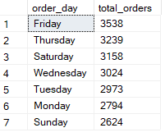

Groups orders by the **day of the week** (DATENAME(DW, order_date)) and counts unique order_id values to show **total orders per weekday**.

2. Hourly Trends

select DATEPART(HOUR, order_time) as order_hours, COUNT(distinct order_id) as total_orders

from pizza_sales

group by DATEPART(HOUR, order_time)

order by total_orders desc;

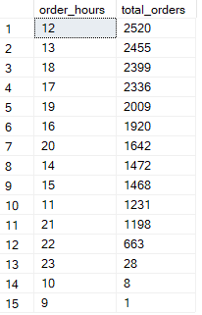

Counts unique orders grouped by **hour of the day**, showing when most orders were placed.

3. Monthly Trends

select DATENAME(MONTH, order_date), COUNT(distinct order_id) as total_orders

from pizza_sales

group by DATENAME(MONTH, order_date)

order by total_orders desc;

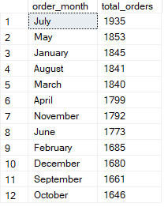

Groups orders by **month name** and counts unique order_id values to get the **total orders per month**.

4. % of Sales by Pizza Category

select pizza_category, SUM(total_price) as total_revenue,

cast((SUM(total_price) * 100) / (select sum(total_price) from pizza_sales) as decimal(10,2)) as PCT_category

from pizza_sales

group by pizza_category

order by PCT_category desc;

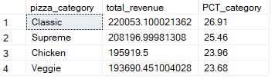

Calculates total revenue per pizza_category and its **percentage share of overall revenue**, then lists results by category.

5. % of Sales by Pizza Size

select pizza_size, SUM(total_price) as total_revenue,

cast((SUM(total_price) * 100) / (select sum(total_price) from pizza_sales) as decimal(10,2)) as PCT_size

from pizza_sales

group by pizza_size

order by PCT_size desc;

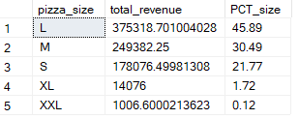

Calculates total revenue per pizza_size and its **percentage of overall revenue**, then orders results by pizza size.

6. Total Pizzas Sold by Pizza Category

select pizza_category, sum(quantity) as total_quantity_sold

from pizza_sales

group by pizza_category

order by total_quantity_sold desc;

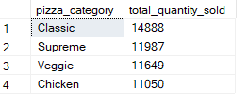

Sums quantity per pizza_category to get **total pizzas sold by category**, then orders results from highest to lowest.

7. Top 5 Pizzas by Revenue

select top 5 pizza_name, round(sum(total_price), 2) as total_revenue

from pizza_sales

group by pizza_name

order by total_revenue desc;

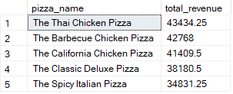

Finds the **top 5 pizzas generating the highest revenue** by summing total_price for each pizza_name and sorting in descending order.

8. Bottom 5 Pizzas by Revenue

select top 5 pizza_name, round(sum(total_price), 2) as total_revenue

from pizza_sales

group by pizza_name

order by total_revenue asc;

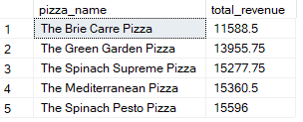

Finds the **5 pizzas with the lowest revenue** by summing total_price per pizza_name and sorting in ascending order.

9. Top 5 Pizzas by Quantity

select top 5 pizza_name, sum(quantity) as total_pizzas_sold

from pizza_sales

group by pizza_name

order by total_pizzas_sold desc;

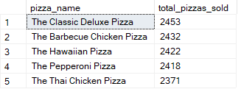

Retrieves the **5 most sold pizzas** by summing quantity for each pizza_name and ordering results from highest to lowest.

10. Bottom 5 Pizzas by Quantity

select top 5 pizza_name, sum(quantity) as total_pizzas_sold

from pizza_sales

group by pizza_name

order by total_pizzas_sold asc;

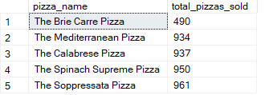

Retrieves the **5 least sold pizzas** by summing quantity per pizza_name and ordering results from lowest to highest.

11. Top 5 Pizzas by Total Orders

select top 5 pizza_name, COUNT(distinct order_id) as total_orders

from pizza_sales

group by pizza_name

order by total_orders desc;

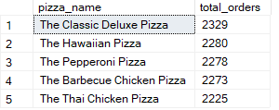

Finds the **5 most frequently ordered pizzas** by counting unique order_id values per pizza_name, sorted from highest to lowest.

12. Bottom 5 Pizzas by Total Orders

select top 5 pizza_name, COUNT(distinct order_id) as total_orders

from pizza_sales

group by pizza_name

order by total_orders asc;

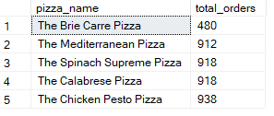

Finds the **5 least frequently ordered pizzas** by counting unique order_id values per pizza_name, sorted from lowest to highest.